DocSpot: Seamless Appointment Booking For Health

1. Introduction
Project Title: DocSpot: Seamless Appointment Booking for Health
Booking a doctor's appointment has never been easier. Traditional methods often involve waiting on hold or playing phone tag with busy receptionists. This project addresses this critical healthcare accessibility challenge by leveraging full-stack web development to create a convenient online platform.
The project aims to develop an intelligent system where users can quickly and effortlessly schedule appointments from the comfort of their own homes. By utilizing the MERN stack (MongoDB, Express.js, React, Node.js), the system provides a seamless bridge between patients and healthcare providers.
The solution employs a user-friendly interface built with React and Ant Design, a robust backend API using Node.js and Express, and a flexible MongoDB database. Users can browse doctors, book appointments, and manage their schedules, while doctors and admins have dedicated dashboards for management.
This practical application of modern web development offers a tool that digitizes and streamlines healthcare scheduling. Ultimately, it has the potential to significantly improve patient experience by reducing wait times and providing real-time availability, making healthcare access more efficient for everyone.
Team Information
- Team ID: LTVIP2026TMIDS90432
- Team Size: 4
Team Members
- Team Leader: Krupa Sagar Villa
- Team Member: Rishitha Anisetti
- Team Member: Veera Bhadra Rao Narla
- Team Member: Rongala Naga Sri Ganesh Vamsi Krishna Mallesh

2. Project Overview
Purpose
To build a full-stack web application that allows patients to book appointments with doctors seamlessly, providing role-based access for patients, doctors, and administrators.

Objective
To develop a system that manages user registrations, doctor approvals, appointment scheduling, and status tracking. The system aims to assist patients in finding healthcare providers and help doctors manage their schedules efficiently.
Project Description
Traditional appointment booking is a fragmented and time-consuming process. This project leverages:
· A React.js frontend with Ant Design for a smooth user interface.
· A Node.js and Express.js backend for handling business logic.
· A MongoDB database for storing user, doctor, and appointment data.
· Role-based access control for Customers, Doctors, and Admins.
The system processes user requests and manages three primary user types:
1. Customer: Can register, view doctors, book appointments, and check status.
2. Doctor: Can manage their profile and view/confirm appointments after admin approval.
3. Admin: Oversees the platform, approves doctor registrations, and enforces policies.
3. Features
User Features (Patient/Customer)
· Account Management: Create an account and log in securely using email and password.
· Browse Doctors: View a list of all available doctors on the dashboard after logging in.
· Book Appointment: Click "Book Now" on a doctor's profile, fill out a form with the appointment date and upload necessary documents.
· Track Status: View the status of appointments (pending, confirmed, cancelled) and receive notifications.
· Manage Bookings: Cancel appointments from the booking history page and update the status accordingly.
Doctor Features
· Registration & Approval: Register on the platform and wait for admin approval to activate the account.
· Appointment Management: View all incoming appointment requests from patients.
· Schedule Control: Confirm or reschedule appointments and update their status based on patient interactions.
Admin Features
· Platform Governance: Manage and monitor overall operations, users, and doctors.
· Doctor Verification: Review new doctor applications and approve legitimate ones to register them in the app.
· Policy Enforcement: Implement and enforce platform policies, terms of service, and privacy regulations, addressing any issues or disputes to maintain a smooth user experience.
4. Architecture
System Architecture
The system architecture of the DocSpot project is designed using a modular approach based on the MERN stack. It consists of four main components:
1. Frontend Layer (React.js)
2. Backend Layer (Node.js & Express.js)
3. Data Layer (MongoDB)
4. User Interface Components
Each component works together to ensure seamless booking and smooth user interaction.
4.1 Frontend Layer (React.js)
· Technologies: React.js, Ant Design, HTML, CSS, JavaScript.
· Components:
· Public Components: Home.jsx, Login.jsx, Register.jsx
· User Components: AddDoctor.jsx, ApplyDoctor.jsx, DoctorList.jsx, UserAppointments.jsx, UserHome.jsx
· Admin Components: AdminDashboard.jsx, AdminUsers.jsx, AdminDoctors.jsx, AdminAppointments.jsx
· Function: Provides the user interface for patients, doctors, and admins to interact with the platform.
4.2 Backend Layer (Node.js & Express.js)
· Technologies: Node.js, Express.js, Mongoose (ODM), JWT for authentication.
· Folder Structure:
· config/connectToDB.js: Handles database connection.
· controllers/: Contains logic for API endpoints (adminC.js, doctorC.js, userC.js).
· middlewares/authMiddleware.js: Protects routes and verifies user identity.
· routes/: Defines API endpoints (adminRoutes.js, doctorRoutes.js, userRoutes.js).
· schemas/: Defines MongoDB models (appointmentModel.js, docModel.js, userModel.js).
· uploads/: Stores uploaded documents.
· Function: Handles HTTP requests, processes data, manages authentication, and interacts with the database.
4.3 Data Layer (MongoDB)
· Database: MongoDB (NoSQL)
· Models (Schemas):
· User: Stores customer/patient data.
· Doctor: Stores doctor-specific data (linked to a User).
· Appointment: Stores all appointment details.

5. Database Design (ER Diagram)
Entity Relationship Diagram
The project uses MongoDB, a NoSQL database. The relationships are managed via references (like foreign keys) between documents.
5.1 User Collection
Field Type Description
_id ObjectId Unique identifier (auto-generated)
name String User's full name
email String User's email (unique)
password String Hashed password
phone String Contact number
isdoctor Boolean Flag indicating if the user is a doctor
type String User role (e.g., 'user', 'doctor')
notification Array List of notifications for the user
5.2 Doctor Collection
Field Type Description
_id ObjectId Unique identifier (auto-generated)
userId ObjectId Foreign Key referencing the User collection
fullname String Doctor's full name
email String Doctor's email
phone String Contact number
address String Clinic address
specialization String Medical specialty
experience Number Years of experience
fees Number Consultation fee
timings String Available hours
status String Approval status ('pending', 'approved')
5.3 Appointment Collection
Field Type Description
_id ObjectId Unique identifier (auto-generated)
userInfo Object Embedded patient details (or reference to User ID)
doctorInfo Object Embedded doctor details (or reference to Doctor ID)
date Date Date of the appointment
document String Path to uploaded document file
status String Status ('pending', 'approved', 'canceled')

6. Setup Instructions
6.1 System Requirements
Software Requirements
· Node.js (version 14 or higher)
· npm (Node Package Manager)
· MongoDB (Local installation or MongoDB Atlas cloud account)
· Git (for version control)
· Code Editor (VS Code recommended)
Knowledge Prerequisites
· HTML, CSS, JavaScript: Basic knowledge for frontend development.
· React.js: Understanding of components, state, and props.
· Node.js & Express.js: Understanding of REST APIs and middleware.
· MongoDB & Mongoose: Understanding of database connectivity and CRUD operations
6.2 Install Dependencies
Step 1: Clone or Download the Project
git clone <repository-url>
cd book-a-doctor
Step 2: Install Backend Dependencies
cd backend
npm install
Key backend packages: express, mongoose, jsonwebtoken, bcryptjs, multer, dotenv
Step 3: Install Frontend Dependencies
cd ../frontend
npm install
Key frontend packages: react, react-dom, axios, react-router-dom, antd, redux-toolkit (optional)
6.3 Run the Application
Step 1: Start the Backend Server
cd backend
npm start
# or node index.js
Expected output: Server running on http://localhost:5000 and connected to MongoDB.
Step 2: Start the Frontend Development Server
Open a new terminal.
cd frontend
npm start
Expected output: The React app will open at http://localhost:3000.

6.4 Access the Application
Open your browser and go to: http://localhost:3000
You will see the Landing Page with options to Login or Register.

7. Folder Structure
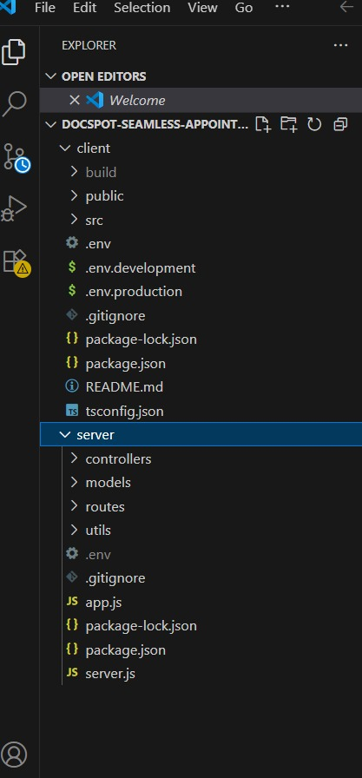

8. Running the Application
- Frontend: Runs automatically via React development server
- Backend: Start Node.js/Express server
Access Application:
- Frontend: http://localhost:3000
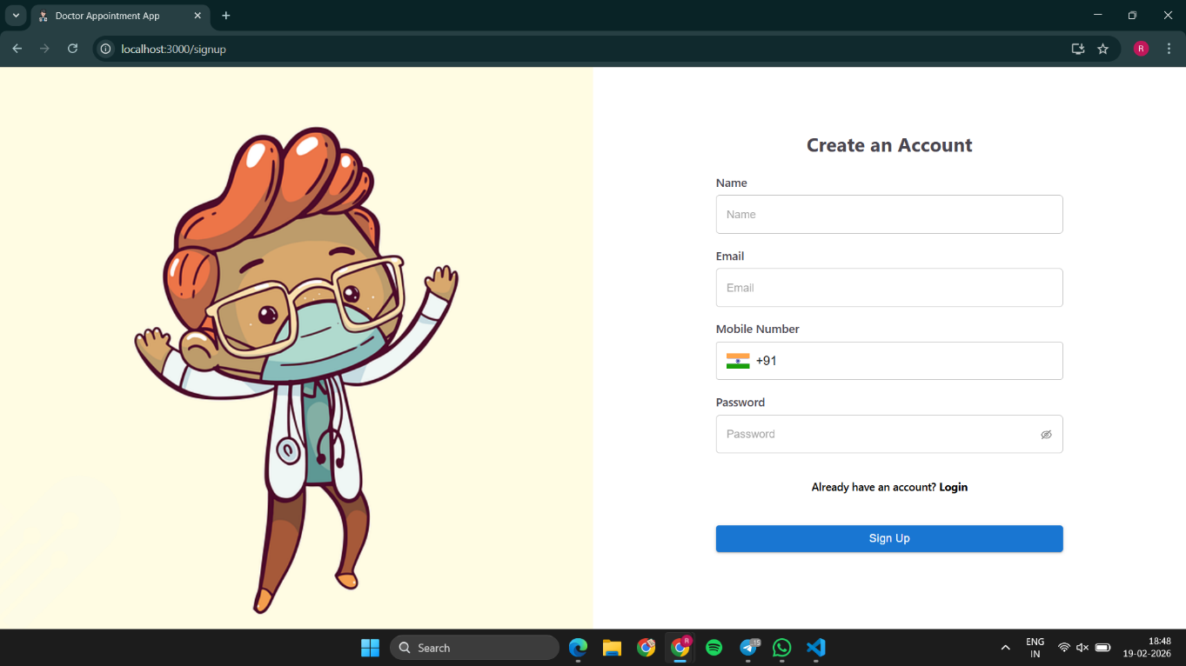
- Backend API: http://localhost:5000
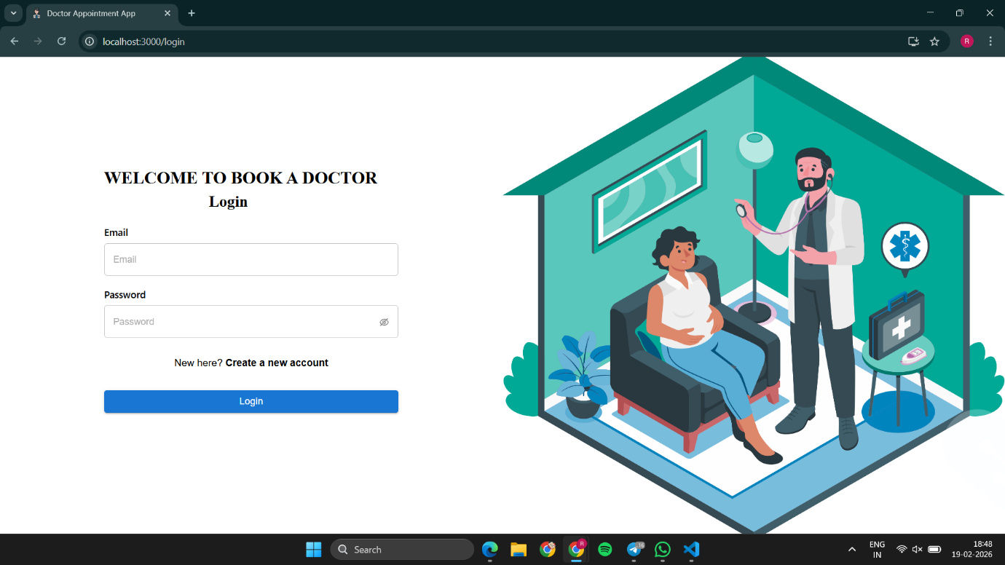
9. Application Flow & API Documentation
Application Flow
The project has three types of users: Customer, Doctor, and Admin.
Customer/Ordinary User Flow:
1. Registers and logs in to the system using email and password.
2. Views all approved doctors on their dashboard automatically.
3. Clicks "Book Now" on a doctor, fills in the appointment date, and uploads necessary documents.
4. Sees the status of their appointment (pending/approved/cancelled) and receives notifications.
5. Can cancel bookings from the booking history page.
Admin Flow:
1. Manages and monitors overall application operations.
2. Reviews doctor applicants and approves them, after which they are registered in the app.
3. Implements and enforces platform policies.
Doctor Flow:
1. Registers and waits for admin approval.
2. After approval, manages all appointments received from users.

10. API Endpoints
- Method Endpoint Description Access
- POST /api/user/register Register a new user Public
- POST /api/user/login Login user Public
- GET /api/user/profile Get user profile Private (User)
- GET /api/doctors Get all approved doctors Private (User)
- POST /api/appointments Book a new appointment Private (User)
- GET /api/appointments/user Get user's appointments Private (User)
- PUT /api/appointments/:id/cancel Cancel appointment Private (User)
- POST /api/doctors/apply Apply to become a doctor Private (User)
- GET /api/admin/doctors/pending Get pending doctor applications Private (Admin)
- PUT /api/admin/doctors/:id/approve Approve a doctor Private (Admin)
- GET /api/admin/users Get all users Private (Admin)
- GET /api/doctor/appointments Get doctor's appointments Private (Doctor)
- PUT /api/doctor/appointments/:id/status Update appointment status Private (Doctor)

11. User Interface (UI)
Design Philosophy
. The UI is designed to be simple, clean, and user-friendly, utilizing modern libraries for a professional look.
Technologies Used
· React.js (Component-based architecture)
· Ant Design (AntD): A React UI library with easy-to-use components for building interactive interfaces. https://ant.design/
· CSS / Bootstrap / Material UI: Used alongside AntD for additional styling.
· React Router: For seamless navigation between pages

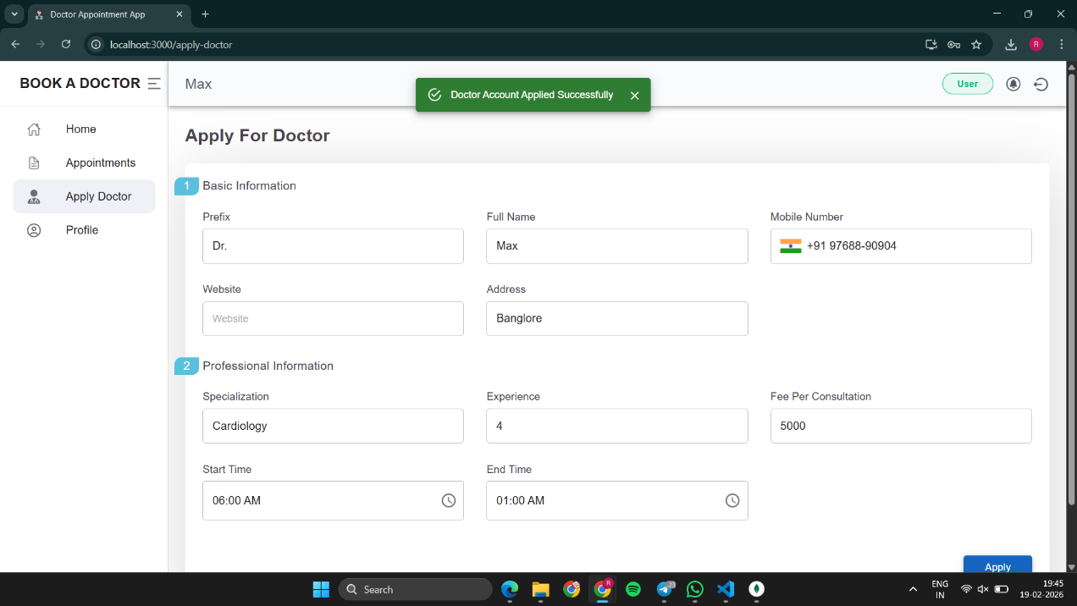
12. Screenshots or Demo
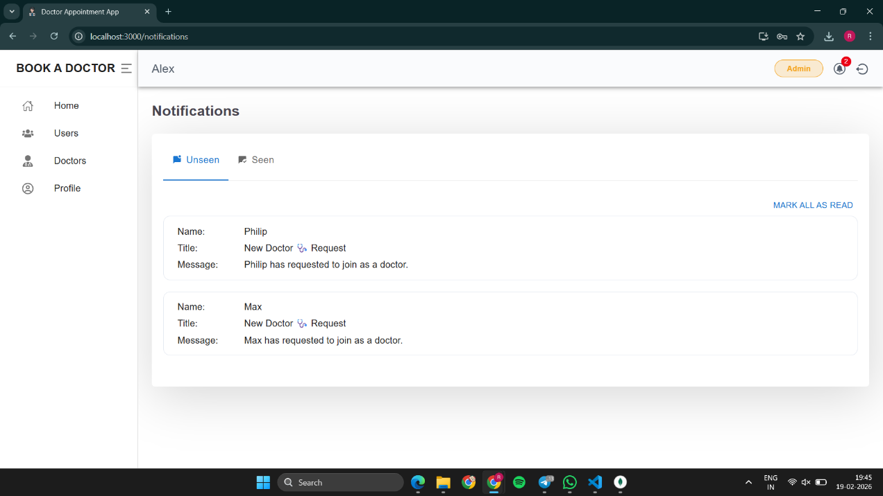

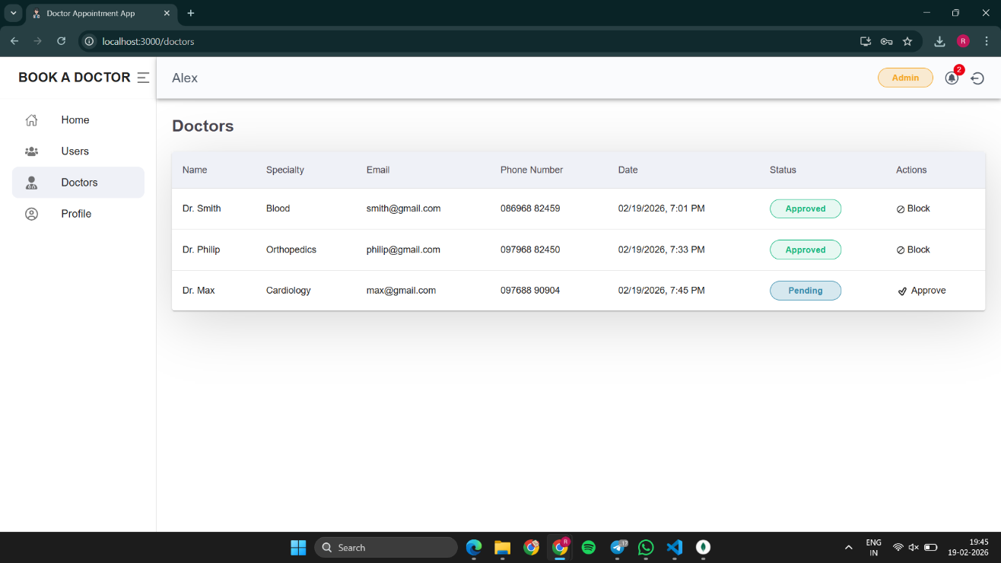

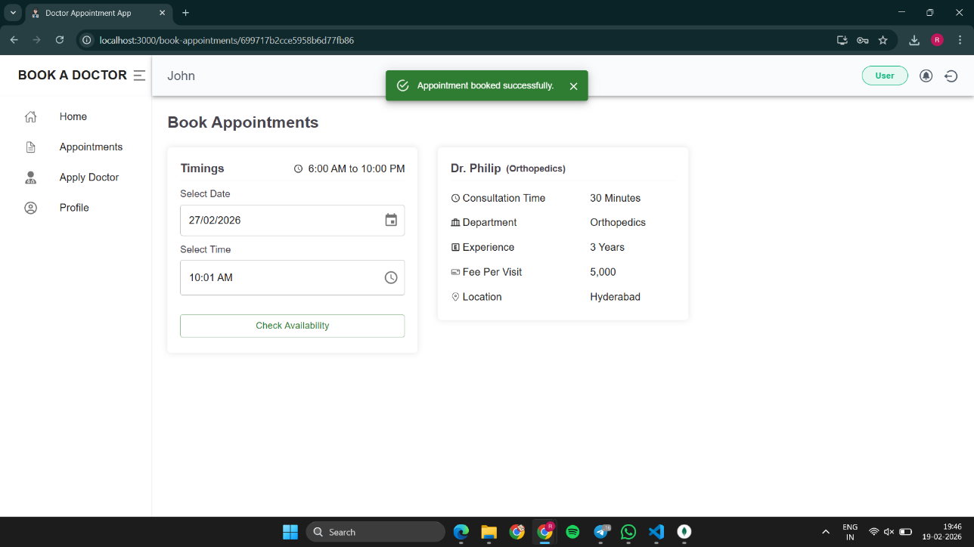

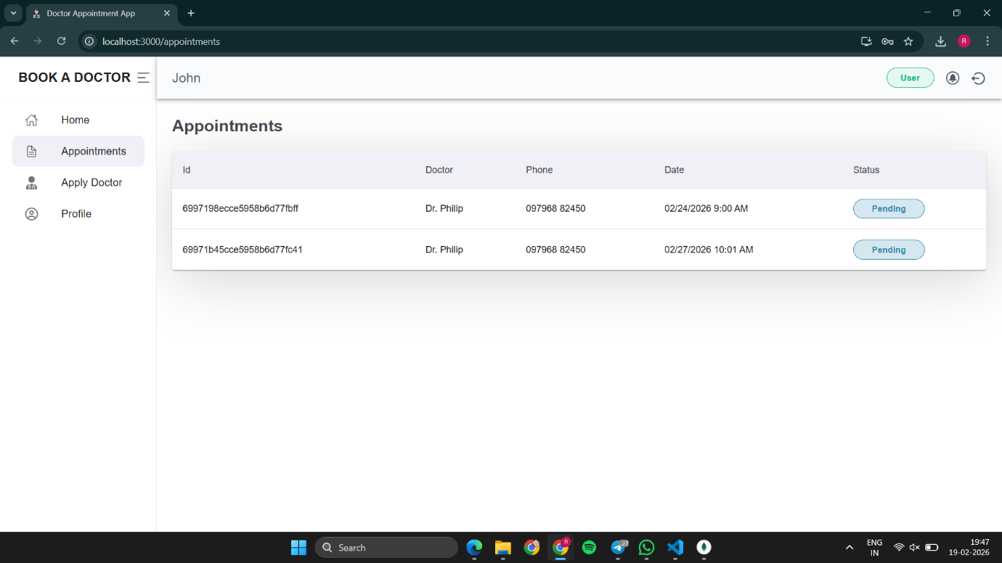

13. Known Issues
· No Real-Time Notifications: Currently, users must refresh to see status updates. Future versions could integrate WebSockets (Socket.io) for real-time alerts.
· Basic Document Upload Security: File validation could be enhanced to prevent malicious uploads.
· Payment Gateway Integration: The current version does not handle online payments for consultation fees.
· Limited Search/Filter: Users can see all doctors but may need advanced filtering by specialization, location, or experience.
· No Video Consultation Integration: The platform currently manages only in-person appointments; telemedicine features could be added.
· TypeScript Configuration: The project has tsconfig.json but may not fully utilize TypeScript throughout all components.
14. Future Enhancements
Although the DocSpot appointment booking system works successfully, several improvements can make it more powerful and industry-ready.

· Real-Time Notifications: Integrate Socket.io or Firebase push notifications to instantly alert users and doctors about appointment status changes.
· Video Consultation Integration: Embed a video calling API (like Zoom SDK or WebRTC) for telemedicine appointments.
· Online Payments: Integrate payment gateways (Razorpay, Stripe) for doctors to collect consultation fees securely.
· Advanced Search & Filtering: Allow users to filter doctors by specialization, location, experience, fees, and patient ratings.
· Reviews & Ratings: Enable patients to leave reviews and ratings for doctors after appointments.
· TypeScript Implementation: Fully migrate to TypeScript for better type safety and code maintainability.
· Cloud Deployment: Deploy the application on cloud platforms (AWS, Heroku, Vercel, Netlify) for global accessibility.
· Mobile Application: Develop a mobile app using React Native for better smartphone accessibility.
· Email/SMS Reminders: Send automated reminders to patients before their appointment time.

15. Conclusion
The DocSpot: Seamless Appointment Booking For Health project successfully demonstrates the application of full-stack web development (MERN) in addressing a common healthcare accessibility challenge.
By leveraging React.js for a dynamic frontend, Node.js and Express for a robust API, and MongoDB for a flexible database, the system achieves seamless appointment scheduling for patients, efficient management tools for doctors, and oversight capabilities for administrators. The project structure is organized into clear client and server directories, promoting separation of concerns and maintainability.
The integration of role-based access control (Customer, Doctor, Admin) into a single web application creates a user-friendly platform where users can register, book appointments, and track their status in real-time. This bridges the gap between patients and healthcare providers, making the process more efficient than traditional phone-based systems.
Through structured development and testing, the project confirms the feasibility of using modern web technologies for digital healthcare solutions. Current limitations such as lack of payment integration or real-time notifications highlight clear paths for future enhancements.
Ultimately, this project serves as a proof-of-concept and scalable foundation for building a production-ready telemedicine platform. It stands as a compelling example of how combining frontend design, backend logic, and database management can create a solution with profound potential to improve the quality of life for millions of patients by simplifying how they access healthcare.

